

Pastor James R. Reynolds, Sr.
1008 Congress Street Portland, Maine 04102
Telephone (207) 774-8192

Sunday School………..10:00 AM
Sunday Worship Service....11:00 AM
Sunday Street Meeting……5:30 PM
Sunday Evangelistic Service……6:30 PM
Wednesday Bible Study……………7:00 PM
Friday Children’s Meeting……6:00 PM

I Timothy 6:10
For the love of money is the root of all evil: which while some coveted after, they have erred from the faith, and pierced themselves through with many sorrows.
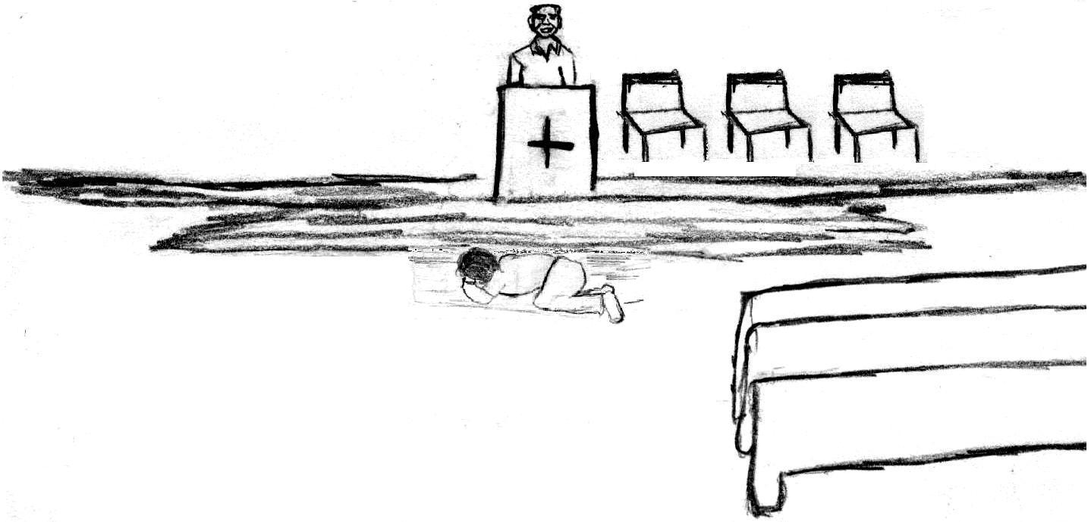
Why can’t you be happy with what you have?
Then its money or this family!

I just can’t give it up!
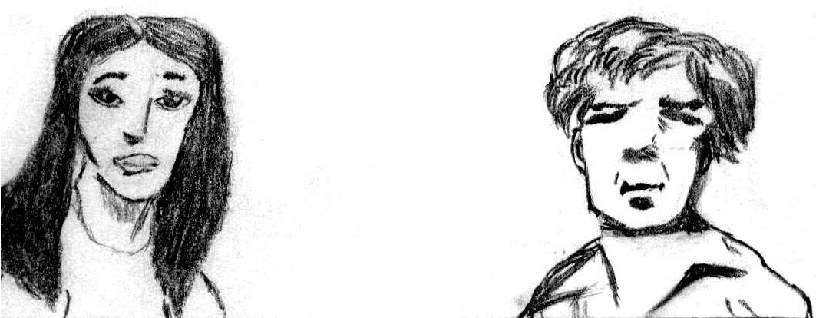
Dear Jesus, I am a sinner and I am sorry. Please forgive me ….

Not ‘til I have my fortune!

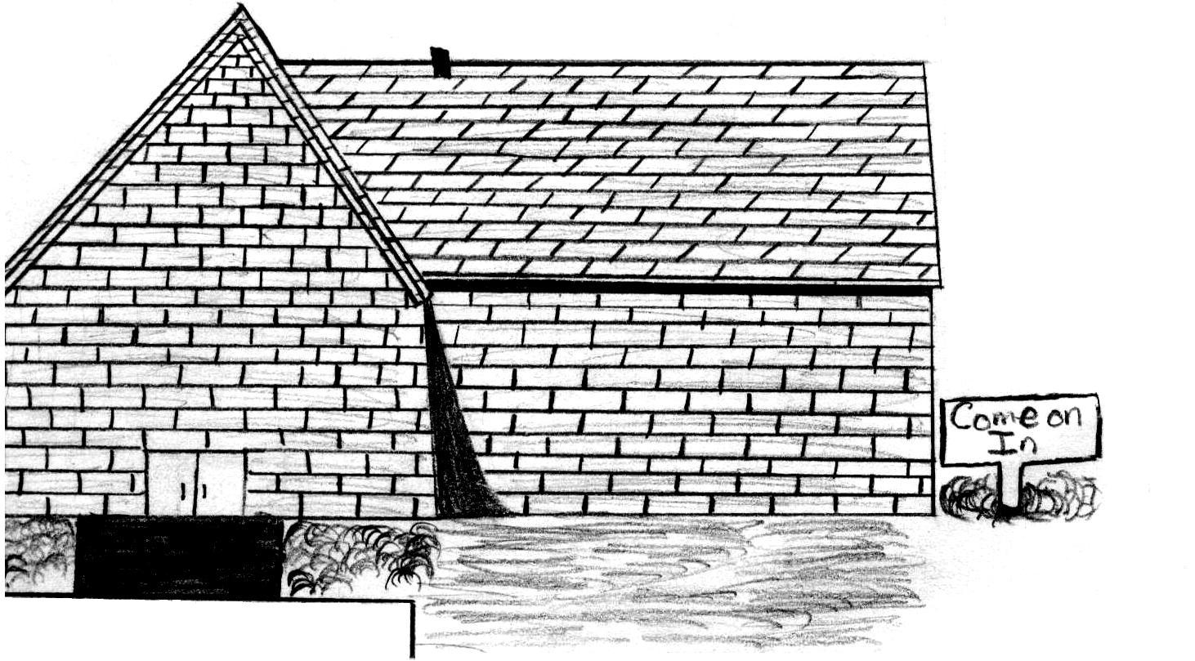
And it came to pass, that the beggar died, and was carried by the angels into Abraham's bosom: the rich man also died, and was buried; And in hell he lift up his eyes, being in torments, and seeth Abraham afar off, and Lazarus in his bosom. And he cried and said,
Father Abraham, have mercy on me, and send Lazarus, that he may dip the tip of his finger in water, and cool my tongue; for I am tormented in this flame. But
Abraham said, Son, remember that thou in thy lifetime receivedst thy
good things, and likewise Lazarus evil
things: but now he is comforted, and thou art tormented. –Luke 16:22-25

Matthew 11:28
Come unto me, all ye that labour and are heavy laden, and I will give you rest..



Matthew 6:24
No man can serve two masters: for either he will hate the one, and love the other; or else he will hold to the one, and despise the other. Ye cannot serve God and mammon.

Joshua 24:15
… Choose you this day whom ye will serve;…

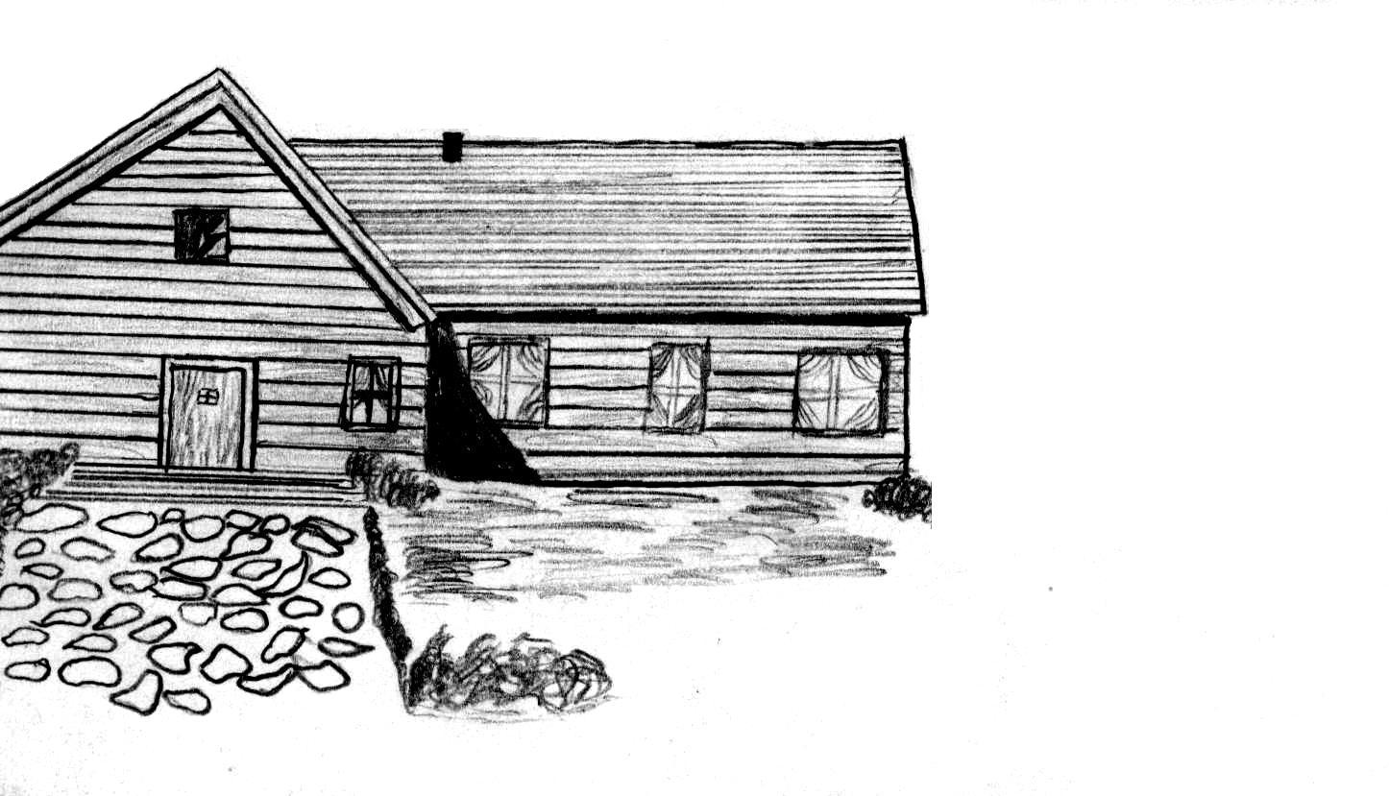
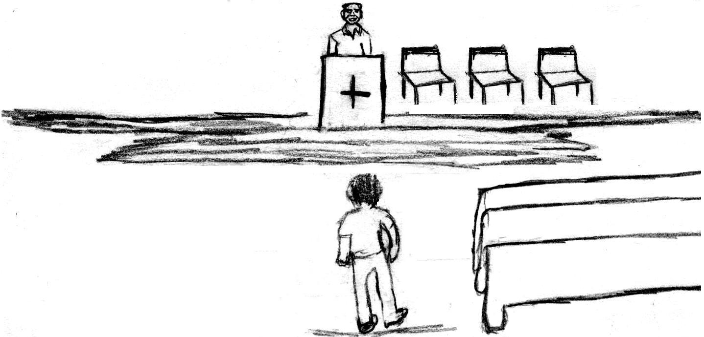
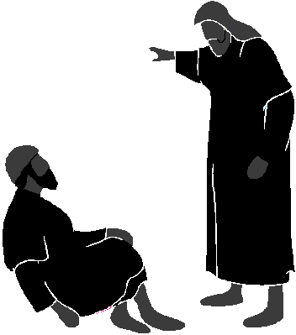

In a town called Canaan there was a man named Jim. Who had a family, a job, and a decent home, but there was one thing Jim didn’t have lots of…Money $$$
Trying to get us a better life!

Jim, where were you?
I’ve lost everything. I can’t give money up. It makes me happy!
Let me tell you a story…
There was a certain rich man, which was clothed in purple and fine linen, and fared sumptuously every day:
And there was a certain beggar named Lazarus, which was laid at his gate, full of sores,
And desiring to be fed with the crumbs which fell from the rich man's table: moreover the dogs came and licked his sores. –Luke 16:19-21

